**COVID 19:**

**SDO BULACAN RESPONSE PLAN**

**INTRODUCTION**

The Department of Education (DepEd) has advised all regions, divisions and schools to create the DRRM COVID 19 Task Force to be spearheaded by the School Health and Nutrition Unit and supported by the Disaster Risk Reduction and Management through DepEd Memorandum No. 15, s. 2020 and other COVID related issuances. The Schools Division Superintendent, together with the Assistant Schools Division Superintendents and Division Chiefs shall ensure the activation of this contingency plan down to the school level and all provisions shall be provided.  
  
 On March 16, 2020, Philippine President Rodrigo Roa Duterte  placed the entire Luzon area in the Philippines under "enhanced community quarantine " (ECQ) which is effectively a total lockdown, restricting the movement of the population with exceptions, in response to the growing Corona Virus Disease 2019 (COVID-19) pandemic in the country. Additional lockdown restrictions mandated the temporary closure of non-essential shops and businesses. This quarantine came two days after the implementation of the community quarantine of Metro Manila.

The quarantine is originally set to last until April 12, 2020 but was extended up to April 30, 2020. The Luzon ECQ caused the mobilization of the Philippine government agencies and local government units as well the passing of Republic Act 11489 or the "Bayanihan to Heal as One Act" in order to fight the COVID-19 pandemic in the Philippines. There are economic, environmental, political, social and cultural impact of the lockdown, affecting around 57 million people being quarantined.

In response to this, the Provincial Government of Bulacan issued *Executive Order No. 14* signed by Governor Daniel R. Fernando on the implementation of *Enhanced Community Quarantine* and *Social Distancing* in Bulacan. Governor Fernando also signed Resolution No. 110, S.220 last March 19, 2020 declaring the Province of Bulacan under state of calamity due to COVID 19.) *(source PDRRMO Bulacan Rescue)*

The DepEd Schools Division of Bulacan did not cease in searching for different ways on how it can deliver its services through competent educators. With this contingency plan, the various units of this institution will respond to the needs of education in the new normal set-up.

1. **OBJECTIVES**

This is the DepEd Contingency Plan for the Corona Virus Disease 19 ( COVID 19). This document was developed by the Disaster Risk Reduction and Management Service (DRRMS), Disaster Management Group members of the Central Office, Regional and Division DRRM Coordinators of the affected and assisting regions.

**This Contingency Plan aims to:**

1. align with the Harmonized National Contingency Plan for the COVID 19 of the National Disaster Risk Reduction and Management Council (NDRRMC);
2. establish the coordination and communication mechanisms with the DepEd Central Office and the affected and assisting regions;
3. set the response and rehabilitation or early recovery roles and functions of the Schools Division Office for purposes of education continuity;
4. provide guidance for the continuing capacity building of DepEd Schools Division Office, District Offices and schools;
5. determine the preparedness, and prevention and mitigation measures to reduce the impacts of the COVID 19; and
6. support the identification of needed equipment and supplies to reduce the impacts of the COVID 19, like personal protective equipment and facemasks.
7. **SITUATION OVERVIEW**

As of July 29 and 30, 2020, there are 1,226 confirmed cases of COVID-19 with 46 deaths in the Province of Bulacan. While there are 392 reported recoveries from virus, there are still 788 total number of active cases in the province’s 21 municipalities and 3 component cities. The tables below show the summary of COVID 19 cases per municipalities and cities.

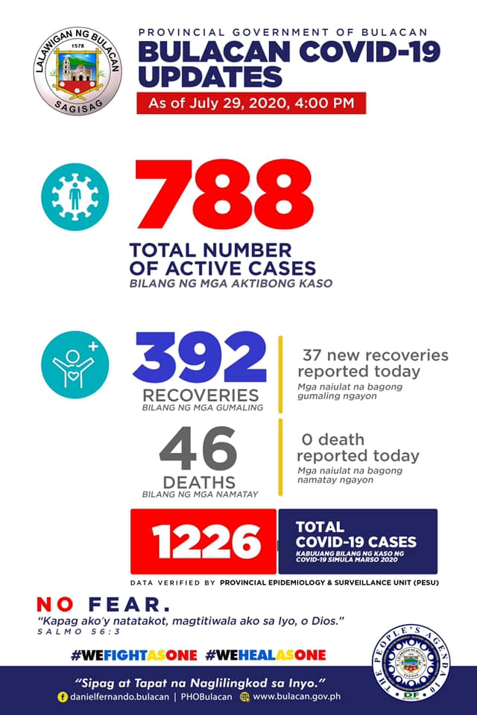

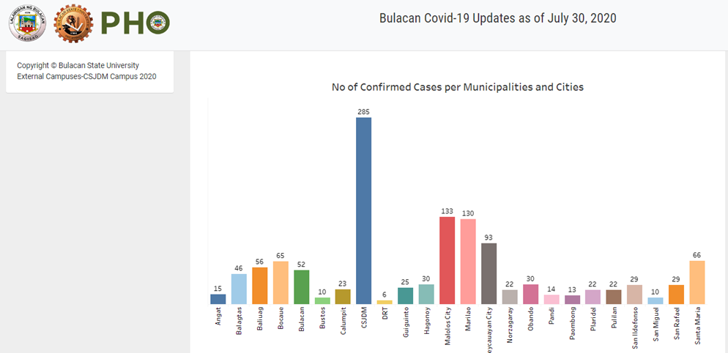

*Source Provincial Health Office*

1. **PUBLIC HEALTH RISKS**

**Older adults and people who have severe underlying medical conditions** like heart or lung disease or diabetes seem to be at higher risk for developing more serious complications from COVID-19. And children aged 20 years old and below are also at higher risk too. These were identified as the vulnerable sectors most of which are learners in different schools in Division of Bulacan.

The virus that causes COVID-19 infects people of all ages. However, evidence to date suggests that two groups of people are at a higher risk of getting severe COVID-19 disease. These are older people (that is people over 60 years old); and those with underlying medical conditions (such as cardiovascular disease, diabetes, chronic respiratory disease, and cancer). The risk of severe disease gradually increases with age starting from around 40 years. It is important that adults in this age range protect themselves and in turn protect others that may be more vulnerable. The World Health Organization (WHO) has issued advice for these two groups and for community support to ensure that they are protected from COVID-19 without being isolated, stigmatized, left in a position of increased vulnerability or unable to access basic provisions and social care. This advice covers the subject of receiving visitors, planning for supplies of medication and food, going out safely in public and staying connected with others through phone calls or other means. It is essential that these groups are supported by their communities during the COVID-19 outbreak. WHO emphasizes that all people must protect themselves from COVID-19, which will also protect others. *( Source PDRRMO Bulacan)*

1. **COVID 19 IMPACT to EDUCATION**

The COVID-19 pandemic is already having a significant disruptive impact on the economy as well as in the Department of Education. Declaration of state of calamity and different modes of community quarantines had a major impact to education and its regular calendar of activities. The DepEd gradually embraces the new normal set-up of providing basic services to teaching, non-teaching and its learners through maximizing the use of social media in the delivery of learning modality.

Based on Republic Act No. 11480 signed by President Duterte on July 17, 2020 which amends Republic Act No. 7797 that states the opening of classes shall be between the first Monday of June until the last day of August, the DepEd shall go on with regular classes using different learning modalities.

1. **THE COVID19 AND ITS IMPACTS**
2. **SCENARIOS**

|  |  |  |  |
| --- | --- | --- | --- |
| **Situation** | **Bad Scenario** | **Worse Scenario** | **Worst Scenario** |
| Descriptions  The situation is in the new normal scenario where the IATF allows the limited face-to-face classes | Classes open on August 24, 2020. Blended learning arrangements including limited F2F is allowed. Minimum health protocols and standards are imposed to ensure the safety of learners, teaching and non-teaching personnel.  **Infection was reported in two (2) schools in one district.**  **Office is 75 % operational** | **Bulacan is placed under GCQ anew after a spike in the number of infected individuals was recorded.**  **The limited F2F is ruled out as an option in delivering instructions and proceeded with the modular base of learning**  **Skeletal work force was implemented** | **Due to continuous elevation on the data of COVID-19 infection in Bulacan, the IATF has declared ECQ where movement of non- essential personnel including children was restricted**  **Only modular learning is recommended but due to community quarantine, teachers were not allowed to go out to deliver modules.**  **Work from home arrangement** |
| Impact on Human Lives |  |  |  |
| 1. Learners | **Children could come to school wearing face masks and face shields, and they could also play in the ground with other children.**  **Frequent hand washing** | **Children were not allowed to go out due to community quarantine.**  **Frequent hand washing** | **Due to the long period of community quarantine, children became anxious.**  **Frequent hand washing** |
| 1. DepEd Personnel | **Coming to office wearing face masks and face shields in dealing with various clients and officemates** | **Other personnel cannot go to office due to localized community quarantine** | **All employees were considered work from home.** |
| 1. Teaching and Non-teaching | **Teaching and non – teaching personnel reported to schools to attend the following**   1. **School/ classroom disinfection** 2. **Important reports** 3. **Attend limited face-to-face classes** | **Few teaching and non- teaching personnel cannot report to school due to pre-existing conditions, others were senior citizens and there are existing localized community quarantine** | **All teaching and non-teaching personnel cannot go to school due to total enhanced community quarantine.** |
| 1. Transportation | **Public**  **transportation is accessible.** | **Limited transportation is accessible.** | **All means of transportation are not accessible.** |
| Impact on Infrastructure, Facilities, and Environment | **School building constructions continue.**  **LGUs submitted request to use school as quarantine facilities (QF).** | **Constructions in COVID high Risk municipalities were suspended.**  **20% of elementary and secondary schools in 33 districts are being used as quarantine facilities (QF).** | **All constructions were suspended.**  **60% of elementary and secondary schools in 33 districts are being used as quarantine facilities (QF).** |
| Response Capabilities | **Responders were able and ready to perform duties.** | **Responders were getting sick.** | **Facilities and responders were overwhelmed.** |

**Table 1. Estimated number of Death, Probable, and Suspected cases (as of August 17, 2020)**

|  |  |  |  |  |  |
| --- | --- | --- | --- | --- | --- |
| **Region** | **Municipalities** | **Death** | **Confirmed** | **Recovered** | **Others** |
| **III** |  |  |  |  |  |
| **Angat** |  | **20** | **18** |  |
|  | **Balagtas** | **1** | **83** | **59** |  |
| **Baliwag** | **2** | **65** | **41** |  |
|  | **Bocaue** | **1** | **87** | **38** |  |
|  | **Bulakan** |  | **69** | **58** |  |
|  | **Bustos** | **1** | **14** | **2** |  |
| **Calumpit** |  | **41** | **8** |  |
| **DRT** | **1** | **7** | **4** |  |
|  | **Guiguinto** | **1** | **43** | **19** |  |
| **Hagonoy** | **2** | **48** | **30** |  |
| **Marilao** | **6** | **215** | **131** |  |
| **Norzagaray** | **1** | **33** | **28** |  |
| **Pandi** | **1** | **26** | **13** |  |
| **Paombong** |  | **21** | **5** |  |
| **Plaridel** | **1** | **72** | **45** |  |
| **Pulilan** | **2** | **39** | **16** |  |
|  | **Obando** | **3** | **63** | **23** |  |
|  | **San Ildefonso** | **3** | **37** | **11** |  |
|  | **San Rafael** |  | **37** | **16** |  |
|  | **Sta. Maria** | **3** | **113** | **21** |  |
|  | **San Miguel** | **1** | **15** | **8** |  |
|  |  |  |  |  |  |
|  |  |  |  |  |  |
| **Total** |  | **27** | **980** | **476** |  |

**Table 2. Exposed Public and Private Schools, Learners, and Personnel( As of August 17, 2020)**

|  |  |  |  |  |  |  |
| --- | --- | --- | --- | --- | --- | --- |
| **Division** | **Public Schools** | **Public School Learners** | **Private Schools** | **Private School Learners** | **Public School Teaching Personnel** | **Public School Non-Teaching Personnel** |
| **Bulacan** | **537** |  | **345** |  |  |  |
|  |  |  |  |  |  |  |
|  |  |  |  |  |  |  |
|  |  |  |  |  |  |  |

1. **Priority Lines of Action**

**Clinical/Medical Response**

Priority Lines of Action

Health and Nutrition Unit Response

|  |  |  |  |
| --- | --- | --- | --- |
| Intervention | Objectives | Expected Outcome | Persons involved |
| Early detection and diagnosis | To provide care / assistance/ treatment in the early stage of the disease through referral system. | The DepEd Division health personnel coordinate with the LGU/RHU re the case. | HNU, DRRM, School Health Coordinators, Personnel Unit, HRDD |
| Reporting of cases/ referral of cases | To provide the official data from School to SDO to RO and CO. | Gather official data of covid 19 cases of deped personnel from RHU through school health /DRRM coor | (if in school) HNU Personnel, School Health Coordinator, School DRRM Coordinator, School Head  (if in SDO) HNU, DRRM, School Health Coordinators, Personnel Unit, HRDD |
| Contact tracing | To trace all possible contacts and isolate them to prevent/ limit the spread of infection. | All closed contacts were identified | if in school) HNU Personnel, School Health Coordinator, School DRRM Coordinator, School Head  (if in SDO) HNU, DRRM, School Health Coordinators, Personnel Unit, HRDD  HNU Personnel, School Health Coordinator, School DRRM Coordinator, School Head |
| Quarantine | To isolate all positive cases, probable and suspected, as well as closed contacts. Monitoring of these patients for 14 days for signs and symptoms and progress of their condition. | 14 days quarantine period must be implemented to closely monitor the condition of the client- occurrence of signs and symptoms, progress and worsening of the condition of the client. | if in school) HNU Personnel, School Health Coordinator, School DRRM Coordinator, School Head  (if in SDO) HNU, DRRM, School Health Coordinators, Personnel Unit, HRDD |
| Disinfection | To conduct daily/ general disinfection of the workplace for safety of all personnel. | Disinfection must be done daily (area / per personnel) and general disinfection (once a week) | if in school) HNU Personnel, School Health Coordinator, School DRRM Coordinator, School Head, Utility workers  (if in SDO) HNU, DRRM, School Health Coordinators, Personnel Unit, HRDD  Supply Officer  Utility Personnel |
| Provision of psychological support to patient and their family | To give psychological support to patient and their family as well as other school and office personnel. | Alleviated fears/ worries of the patient and their families, and other personnel within the school/ SDO | HNU  School Health Coordinators  DRRM Coordinators Guidance Counselor |
| Suggest Lockdown | To contain the spread of disease and give to internal contact tracing | Lessen the increase of community transmission in the work area | SDS, ASDS, SDO Chiefs, HNU and DRRM |

1. **Multi-sector support, including Logistics**
2. Sustain multi-sectoral critical services, both in-kind and through cash-based interventions. Strengthen logistics support.

|  |  |  |
| --- | --- | --- |
| Industry/ Company | Expected Donation | Time Frame |
| Bulacan Paraluman Lions Club | Medical Supplies (face mask, Face shields etc) | August -September 2020 |
| Yolanda N. Tayde | Face mask | August-September 2020 |
| Amalia Santos | Vitamin C | September – October 2020 |
| Catherine E. Sosing | Vitamin C | September – October 2020 |
| Pascual Laboratories | Vitamin C | September – October 2020 |

1. **Establishment of Quarantine Control Points**

|  |  |
| --- | --- |
| **Schools requested to use as Isolation Facility** | **Number of Isolation Rooms** |
| 1. Gen. Gregorio Del Pilar Integrated School | 4 |
| 1. Tibig ES, Bulakan | Pending for Approval |
| 1. 14 elem schools in Guiguinto District | For evaluation and pending approval (as of August 17, 2020) |

1. **ACTIVATION, DEACTIVATION, AND NON-ACTIVATION OF CONTINGENCY PLAN**

The contingency measures in this document align with the 2019 NDRRMC Harmonized National Contingency Plan (HNCP) for COVID-19 Pandemic. This will enable to have better coordination horizontally, i.e. DepEd with other NDRRMC agencies, and vertically, i.e. DepEd Central Office down to the schools.

**A. Activation** - The contingency plan shall be activated and implemented based on the risk situation of the COVID-19 pandemic in the province upon the pandemic’s duration. Afterwards, the Regional Director directs the Schools Division Superintendents and School Heads who shall mobilize and implement necessary responses and mitigation actions in the divisions down to the school level across the region.

**B. Deactivation**- In case that a vaccine and treatment are already available and upon the declaration of the Secretary of DOH, RD’s, SDS’s and school heads and the recommendation of IATF or other authorized agencies and government officials. The Regional Director, through Regional DRRMC if it approves recommendation for demobilization and deactivation of the CPs and Normal Alert Status.

**C. Non-activation** – When the response plan is enough for the needs of the affected individual of all the LGU’s, the Contingency Plan will not be activated anymore.

**Coordination Structure**

**Structure of the Incident Management Team**

Gov. DANIEL R. FERNANDO

Provincial Governor

DR. NICOLAS T. CAPULONG, CESO V

DR. CECILIA E. VALDERAMA

ROWENA T. QUIAMBAO

Responsible Officials

ALL LGUs

COMMAND STAFF

MARCOS M. DELA CRUZ

Incident Commander for Operation

DR. GREGORIO C. QUINTO

Incident Commander for Curriculum

BRYAN AMIEL F. DE JESUS

Liaison Officer

RAINELDA M. BLANCO

Public Information Officer

CARL PAULO A. FERNANDO

Safety Officer

GENERAL STAFF

PEDRO G. LACAP

Operation Section

MARIA M. SALCEDO and ALICE A. ALMAZAR

Finance /Admin Section

RAQUEL I. CLIMACO

Logistic Section

PAULO EDUARDO C. CRUZ

Planning Section

DR. CARLO CASTILLO

Medical Unit Leader

SHIRLEY C. BURGOS

First Aid Group Leader

YOLANDA JIMENEZ

First Aid Group Leader

LEANDRO BALUYOT

First Aid Group Leader

DR. JAY-AR SANGOYO

Evacuation Unit Leader

**A. FINANCIAL REQUIREMENTS**

The expenses to the activities to be undertaken in implementing this contingency plan may be charged against the Maintenance and Other Operating Expenses (MOOE) and DRRM realigned funds and other COVID 19 response funds.

|  |  |
| --- | --- |
| **Response Pillars** | **Amount** |
| Health monitoring |  |
| Risk Reduction and Communication |  |
| Office Disinfection |  |
| Food |  |
| Protection |  |
| Meeting and orientation |  |

1. **Response and Early Recovery Measures of DepEd Central Office, Affected Regions, Schools Divisions and Schools**
2. BEFORE (Preparedness and Preventive Action)

|  |  |
| --- | --- |
|  | **Action To Be Taken** |
| Week 1 | · Request for purchase of additional materials and equipment  · Posting of IECs, and Information Dissemination in all media plot forms of DepEd Bulacan  · Crafting of Contingency Plan  · Online Health Monitoring of personnel  · Implement the DOH minimum health standards |
| Week 2 | · Ensure availability of alcohol / hand sanitizers and disposable rags for all personnel and guests.  · Checking and Monitoring the health status of personnel and students’ via HNU  · Disinfection of the Schools Division Office every Saturday or as the need arises. |
| Week 3 onwards | · Online Health Monitoring of personnel  · Continuous monitoring of the execution of ConPlan  · Attend Mental Health Psychosocial Support webinars  · Conduct of awareness campaign and webinars (MHPSS/Contact Tracing/COVID-19 related information and updates)  · Proper endorsement of requests for use of schools as quarantine/isolation area and other COVID-19 purposes in coordination with DRRM. |

**B. DURING (If outbreak occur)**

|  |  |
| --- | --- |
|  | **Action to Be Taken** |
| 0 – 24 hrs | · Online Health Monitoring of personnel  · Containment of PUIs/ Monitoring by Division Nurses  · Reporting of cases in SDO Covid Taskforce, LGU (DOH)  · Mandatory quarantine of persons with suspected cases and close contacts  · Referral to Health Facility, if necessary  · Alternative Work Arrangement (AWA) for employees |
| 25 – 48 hrs | · Provide service vehicle to skeletal workforce  · Online Health Monitoring of personnel  · Analysis on the extent of outbreak and crafting of further action  · Monitoring of PUIs and Covid 19 patients  · Disinfection of office/school premises.  · Referral to Health Facility, if necessary  . Office Disinfection |
| 72 hours onwards | · Issuance of face shields per shift to skeletal workforce.  · Proper endorsement of requests for use of schools as quarantine/isolation area and other COVID-19 purposes in coordination with DRRM.  · Online Health Monitoring of personnel  · Continuous monitoring of the case.  · Remote PFA/MHPSS in collaboration w/Guidance counselors/Nurses/School DRRM  · Disinfection of offices every week.  · Referral to Health Facility, if necessary  Distribution of MHPSS/ PFA Modules |

C. AFTER

|  |  |
| --- | --- |
|  | **Action to Be Taken** |
| Once vaccine is available | · Ensure that all personnel should have vaccine shot/ immunization for COVID 19 pandemic.  · Disinfection of offices every week.  · Alternative Work Arrangement for employees, if possible  · Online Health Monitoring of personnel  · Ensure availability of alcohol / hand sanitizers, disposable rags for all personnel and guests.  · Strict implementation of minimum health standards issued by DOH. |

**Prepared by: Reviewed by:**

**PEDRO G. LACAP MARCOS M. DELA CRUZ**

**PDO II SGOD Chief**

Recommending Approval

**ROWENA T. QUIAMBAO, CESE**

Assistant Schools Division Superintendent

**CECILIA E. VALDERAMA, PhD**

Assistant Schools Division Superintendent

Approved

**NICOLAS T. CAPULONG, PhD. CESO V**

Director III and Concurrent Schools Division

Superintendent